**दॆवनागरिलिपि**

Nothing (+Capslock)

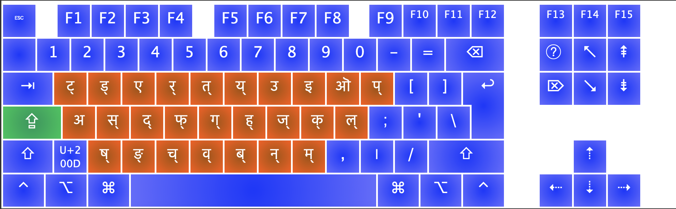

With Shift On (+Capslock)

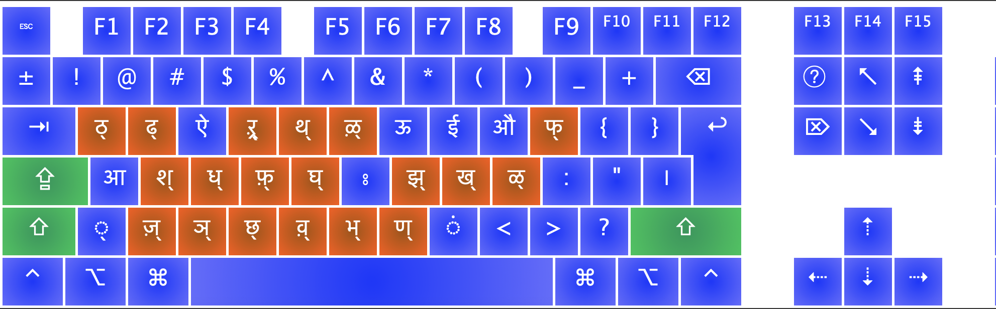

With Options On (+Capslock)

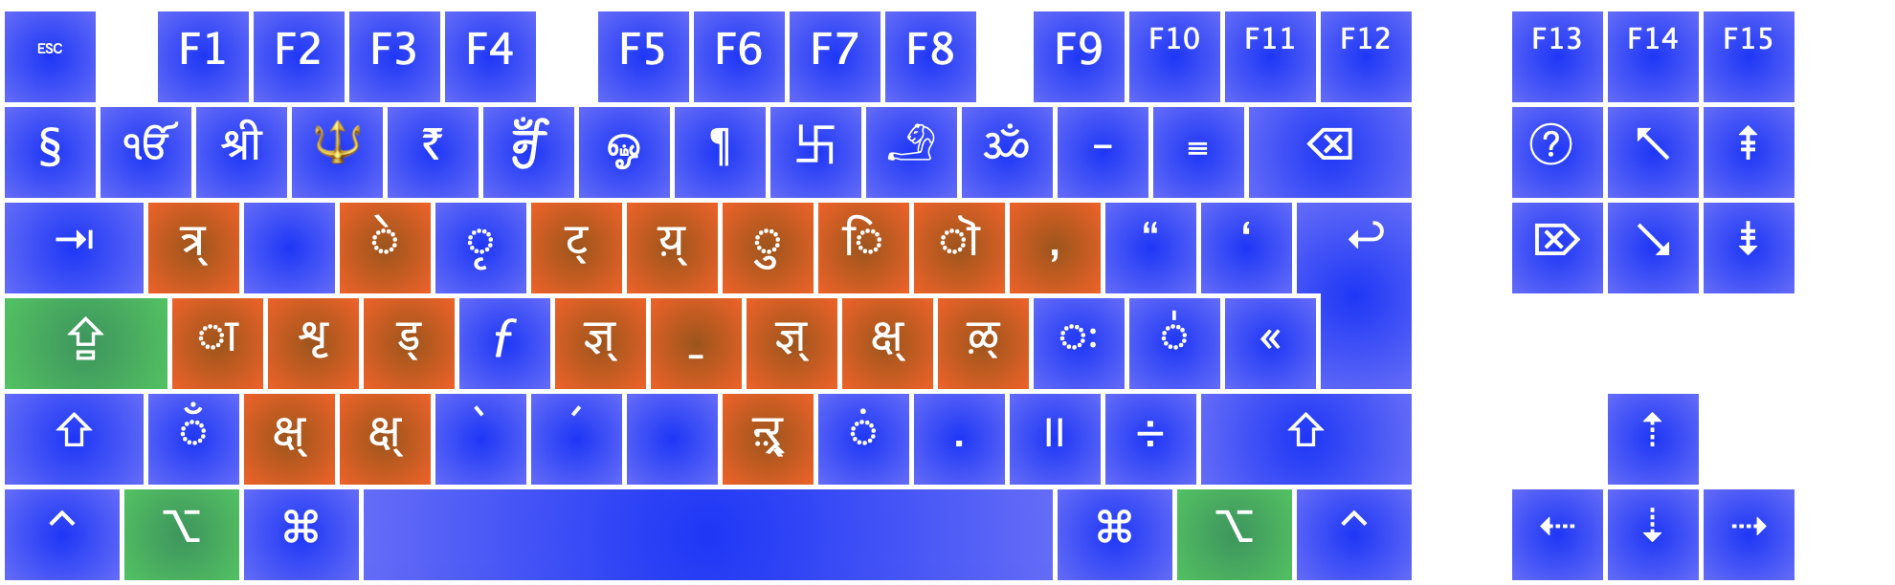

With Shift & Options On (+Capslock)

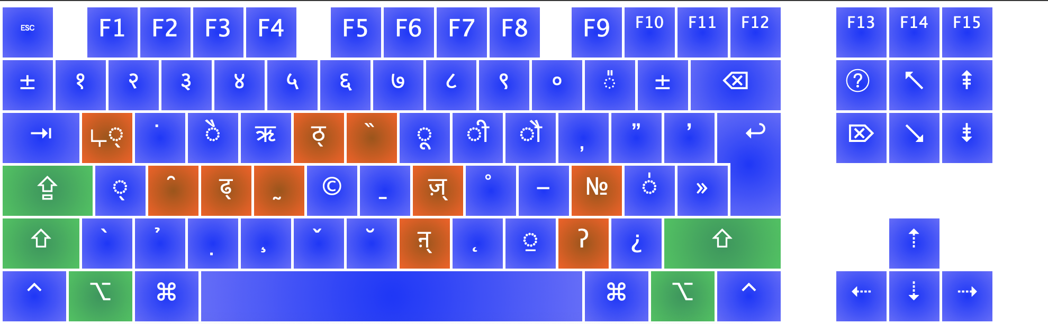

**മലയാളഗ്രന്ഥലിപി**

Nothing (+Capslock)

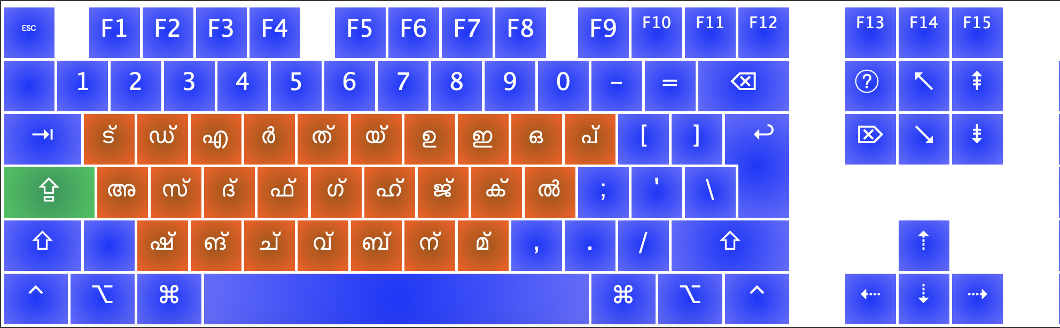

With Shift On (+Capslock)

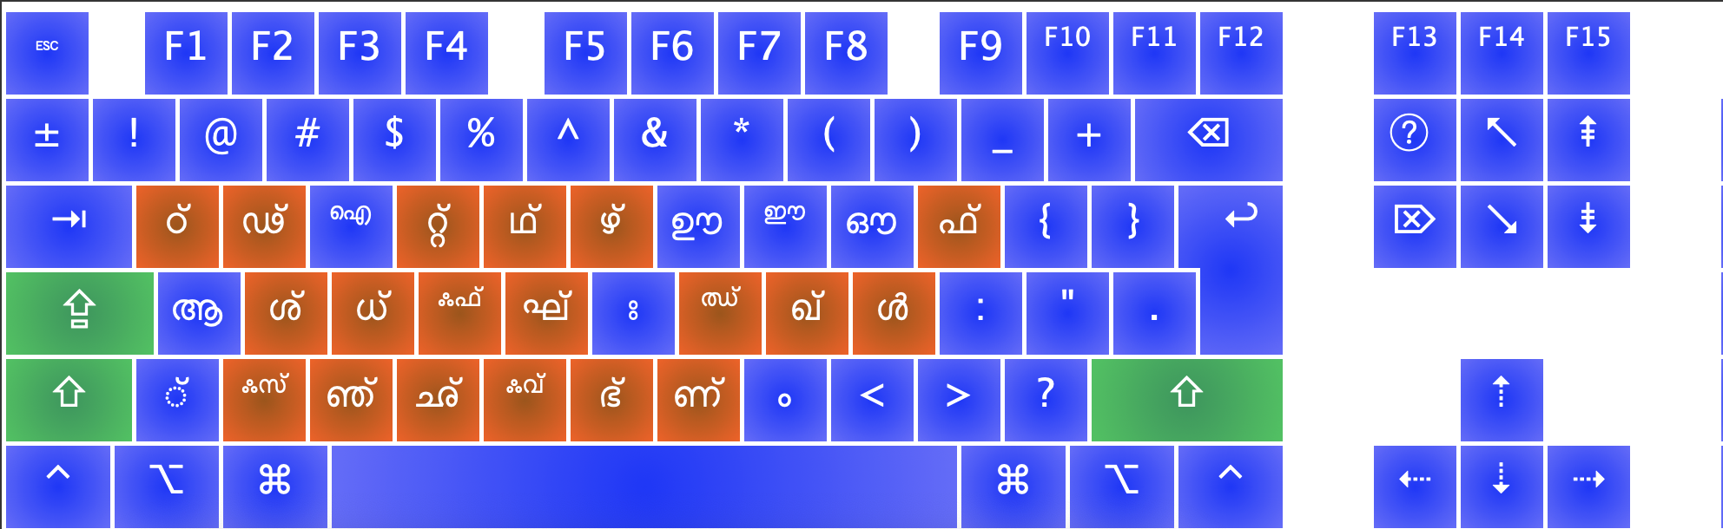

With Options On (+Capslock)

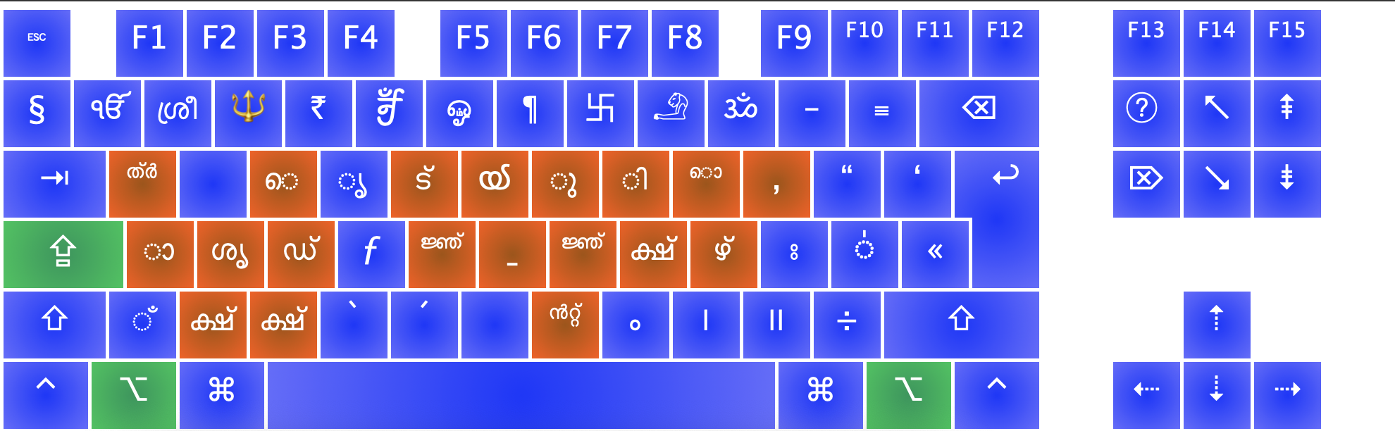

With Shift & Options On (+Capslock)

